Firewall Game Design

# Attacker

1. NMAP using coins or previous knowledge of ports to target open ports
2. Ip spoofing: Player selects various different combinations of 4 numbers to make an IP which connects to target server. Hints will be given which players can use to reduce the time taken. The hints will be like “IP address from India are restricted“ so 192.x.x.x are not viable option.
3. HTTP Header filtering : Players can choose different combination of headers to check which ones are accepted by the firewall. Players can use hint given like “website requires redirection”
4. At last when **attack is occurring** questions come in form of MCQ’s and the player needs to answer them in order to maintain the stable connection.

# Defender

# 

1. Company policy allows only some specific ports to be open. On using tools like NMAP the player must find out the open ports which are unauthorised and close them using appropriate functions.

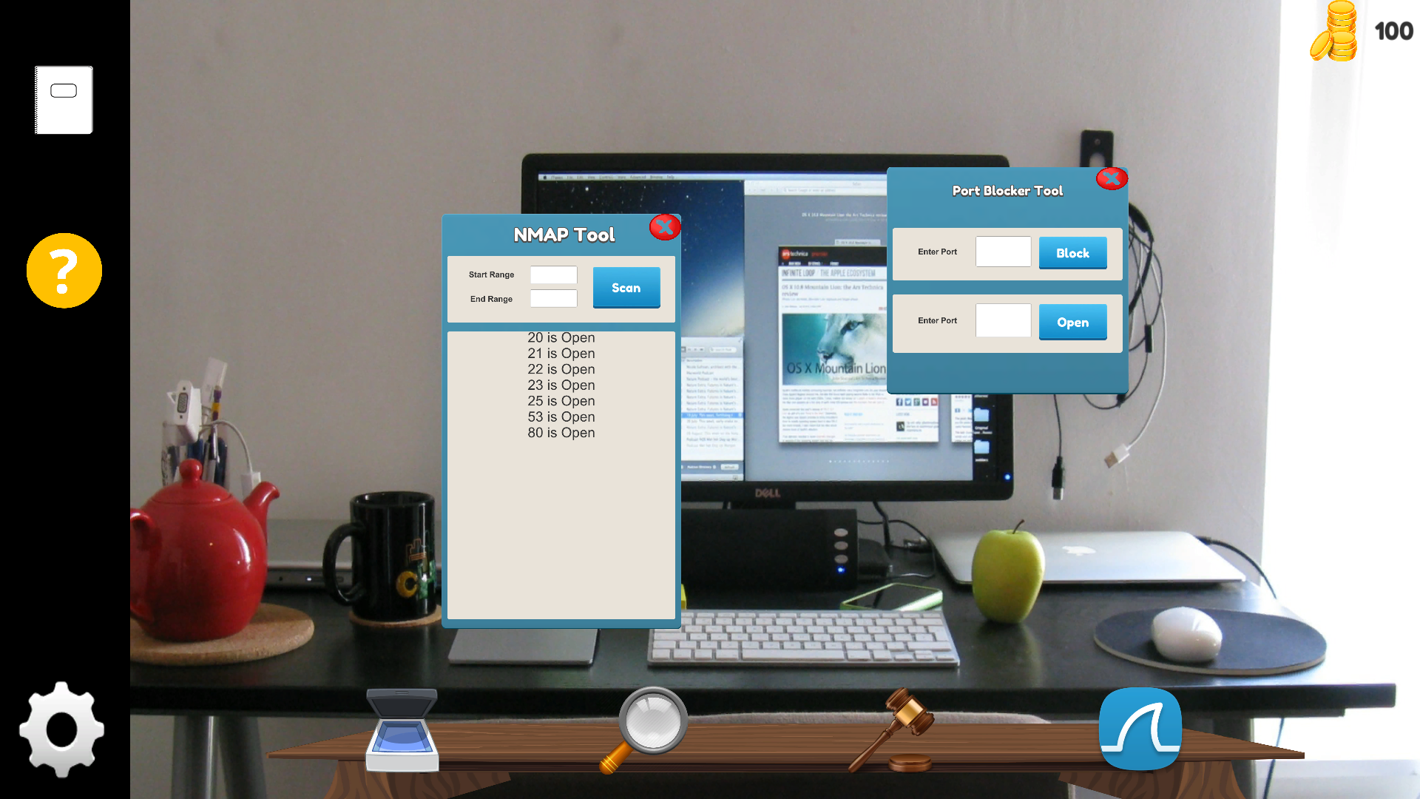

1. Packet validity analysis: Some external packets are spoofed to act like internal packets. Player need to find out he external packets using the information provided such as previous node, Source Node. Ex : at **3**, source node states **1** but previous node states **4** , which is not possible.. Therefore the packet is spoofed. Assumption : Packets follows least distance rule

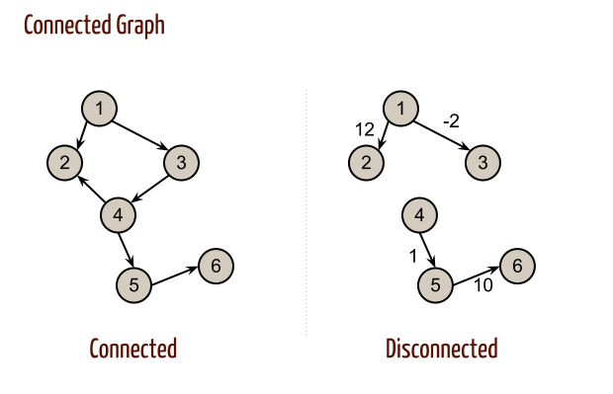

1. Optimal IP range finder: Set the limits of a slider to exact optimum IP range such that all company connections are covered and external connections are cut off.

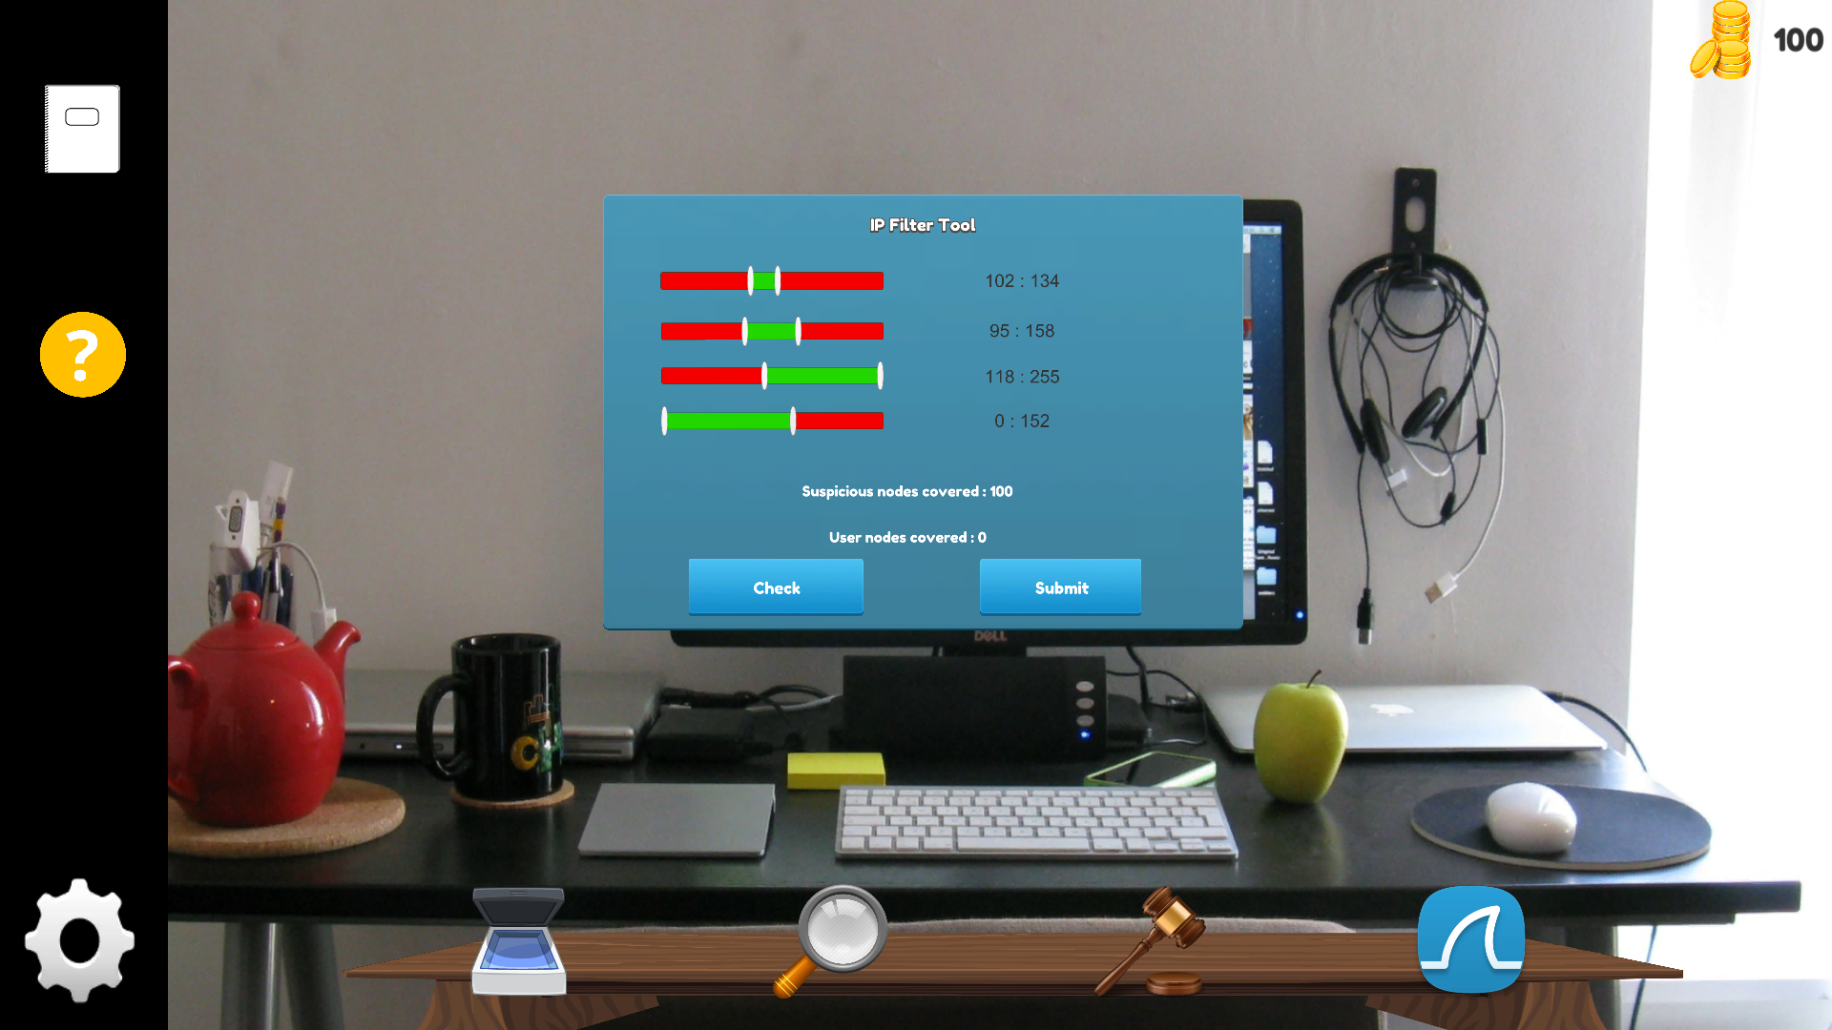

1. ~~Watch the wireshark data to analysis and block the suspicious data flow. (large data flow in a port – only SYN no ack)~~
   1. ~~Line by line rendering of the data in unity as text~~
2. Configure rules of firewall in a given scenario
   1. Protocols
   2. Source port, address
   3. Dest port ,address
   4. Established/related
   5. Interface block : wifi,eth0 etc

* Timed game
  + Set of objectives to be met
  + Extra rules will be penalised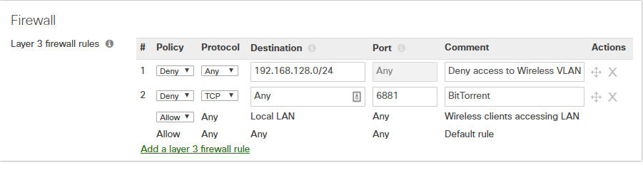
  + Show some mini game as a motivation factor
    - Drag and drop rules into a board